**About Chennai:**

Chennai is the [capital](https://en.wikipedia.org/wiki/Capital_city) of the [Indian state](https://en.wikipedia.org/wiki/States_and_territories_of_India) of [Tamil Nadu](https://en.wikipedia.org/wiki/Tamil_Nadu). Located on the [Coromandel Coast](https://en.wikipedia.org/wiki/Coromandel_Coast) off the [Bay of Bengal](https://en.wikipedia.org/wiki/Bay_of_Bengal), it is one of the biggest cultural, economic and educational centres in South India. Chennai attracts 45 percent of [health tourists](https://en.wikipedia.org/wiki/Medical_tourism) visiting India, and 30 to 40 percent of domestic health tourists. As such, it is termed "India's health capital". The [Chennai Metropolitan Area](https://en.wikipedia.org/wiki/Chennai_Metropolitan_Area) is one of the largest city economies of India. Chennai is nicknamed "The Detroit of India", with more than one-third of India's automobile industry being based in the city. The city also houses India's Tamil ([Kollywood](https://en.wikipedia.org/wiki/Kollywood" \o "Kollywood)) film industry.

**Top places to visit in Chennai:**

**Marina Beach:**

Marina beach is the second longest beach in the World and runs to a length of 13 Km.   
Situated on the beach, the Anna Park, named after the founder of D.M.K Anna Durai and the tomb of M.G. Ramachandran who was a film star (both were former Chief Ministers of Tamil Nadu) and the Statue of Labour is a splendid sculpture depicting the efforts of a team of labourers who are at hard manual labour. The beach can be ideally visited in the early mornings or in the late evenings when the area becomes a virtual ground with food stalls and other entertainments.

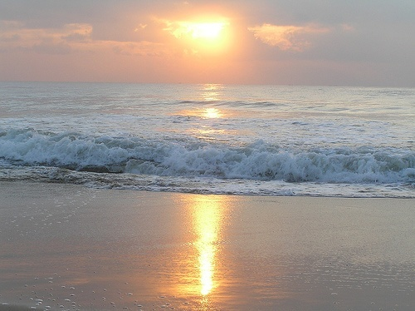

**ARIGNAR ANNA ZOOLOGICAL PARK:**

Arignar Anna Zoological Park is one of the finest zoos in India. The park shelters more than 170 species of animals. The dry forests surrounding the Vandalur region is the ideal breeding ground for these animals. It is home for Tigers, Jaguars, Lions, Panther, Elephants, Sambar, Giraffes and many more. The Park has a library with good collection of wildlife related books and information. Elephant safari is also available in the park.

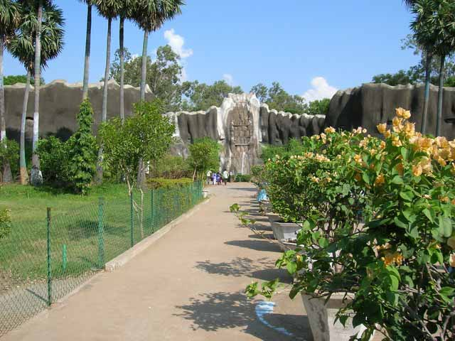

# V.G.P. GOLDEN BEACH

VGP Golden Beach is the only resort in Chennai city limits. This Beach cum Amusement Park is developed by The Tourism and Entertainment Corridor of Tamil Nadu, and offers wide range of entertainment options like Go-karting, Dashing Cars, Water Chute, Giant Wheel, Break-dance, Dragons belly, Super trooper and many more. Kids can enjoy the special sightseeing of Jurassic Park and Aquarium.

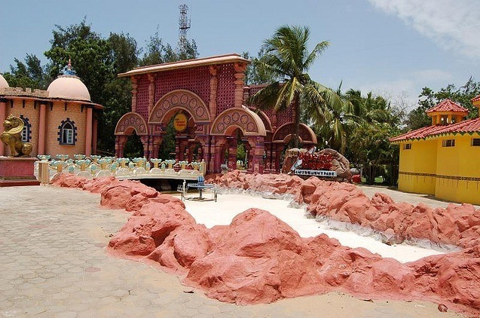

## **Mahabalipuram:**

Mahabalipuram is situated in Kanchipuram district in the state of Tamil Nadu. It is famous for its shore temples built in 7th century. It is known for its historical monuments, sculptures, scenic beauty, culture and tradition.The famous Arjuna's Penance and the Krishna Mandapa adorn massive rocks near the centre of the village. The beautiful Shore Temple towers over the waves, behind a protective breakwater.   
  
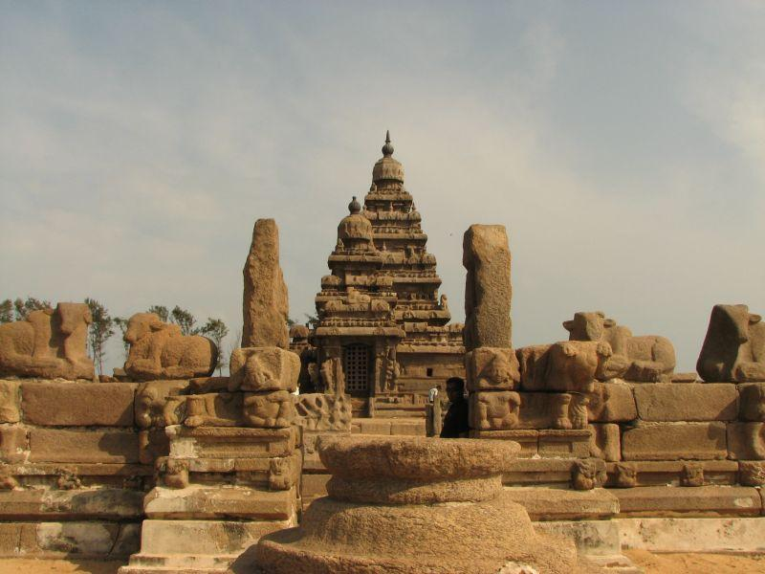

#### **Vedanthangal Bird Sanctuary:**

Vedanthangal has the reputation of being one of the oldest water bird sanctuaries in India. It is said that almost 100,000 avian species visit this sanctuary between October and March. Records reveal that this sanctuary has been in existence for more than 200 years. This area was the favorite hunting spot for the local landlords some 300 years ago. for the birds.   
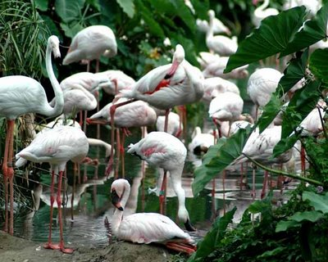

# SNAKE PARK:

Established in 1972, the park has been home to a wide range of snakes, from the deadly King Cobra to pythons, vipers and other reptiles. The Snake Park has become a breeding point of endangered pythons in the country. A museum of preserved specimens of reptiles and amphibians is an added attraction.  
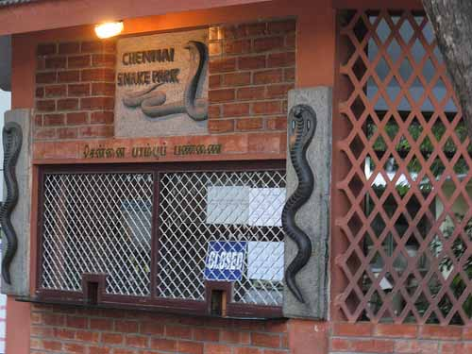

# BIRLA PLANETARIUM:

The Birla Planetarium is the most modern planetarium in India. It houses a fully computerized projector that depicts the heavens on a hemispherical dome. The Planetarium presents audiovisual programs on various themes in astronomy. 

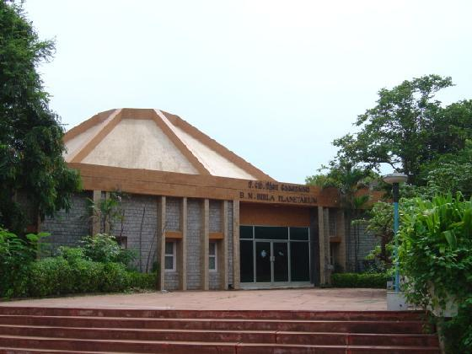

# VALLUVAR KOTTAM:

Valluvar Kottam is a monument built to pay homage to Tamil Poet Saint Thiruvalluvar.  
Inaugurated in 1976, the memorial is the form of 101-feet high temple chariot and is the replica of the temple chariot in Thiruvarur. A 33m tall life-size statue of the saint has been installed in the chariot. Another amazing attribute of the auditorium is that it is not supported by a single pillar and stands without any support.  
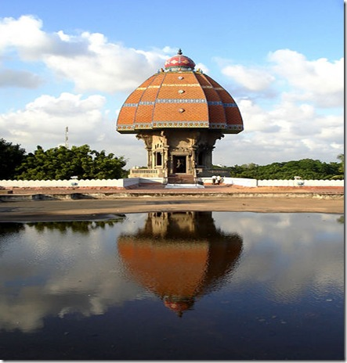

# ELLIOT'S BEACH:

The Elliot's Beach is a well-known destination for people who seek relief from the crowded metropolitan life of the [Chennai](https://www.trawell.in/tamilnadu/chennai). The Adyar River drains into the sea here. Popularly known as 'Bessie' among locals, this is an extremely calm and tranquil place. The Beach has become a popular hangout for the young generation. Elliot's Beach is also a favorite haunt of foreigners where they can peacefully take their sun bath.  
  
